**Peter Pan Inn corn fritters**  
Makes about 18 fritters  
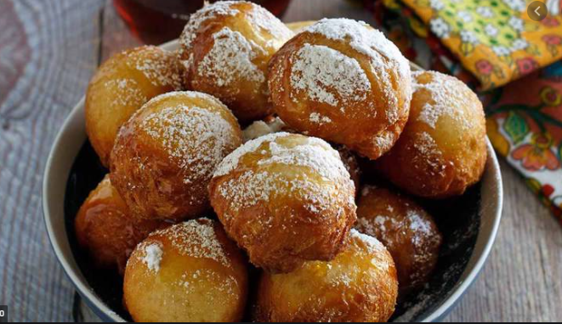

**Ingredients**  
1 1/4 cups flour  
1/2 teaspoon salt  
3 tablespoons sugar

1 1/2 teaspoons baking powder

1 egg, beaten

1/2 cup milk

1 cup whole corn kernels, drained

powdered sugar

**Directions**

1. Sift the dry ingredients together. Add the wet ingredients to the dry and mix well but take care not to overmix.
2. Drop by spoonfuls into hot oil and fry until golden brown.   
   Drain on paper towels and dust with powdered sugar.